In the textbook, and 2023_Week_8, there should be correction in definition about passivity

* **Definition on Passivity**

At page 117 in the textbook

* Def.5.1 The system $y=h(t,u)$ is **Passive if $u^{T}y≥0$, should be**

**Passive if $\int_{0}^{t}{u^{T}\left(τ\right)y\left(τ\right)dτ≥0 } ∀t≥0 , ∀ u , y\left(0\right)=0$**

* Def. 5.3 Passivity in the state space (This is appropriate)

C:\Users\김태욱\AppData\Local\Temp\ConnectorClipboard1569609851702836570\image16860120359100.png

The system (5.6) is **passive** if C:\Users\김태욱\AppData\Local\Temp\ConnectorClipboard1569609851702836570\image16860120359181.pngcontinuously differentiable **positive semidefinite function** (here called as the **storage function)** s.t.

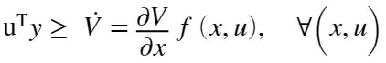

Moreover

* Loseless if $u^{T}y = \dot{V}$
* Input strictly passive if $u^{T}y≥ \dot{V}+u^{T}φ\left(u\right)>0, and u^{T}φ(u)>0, ∀ u≠0$
* Output strictly passive if $u^{T}y≥ \dot{V}+y^{T}ρ\left(y\right)>0, and y^{T}ρ\left(y\right)> 0, ∀ u≠0$
* **Strictly passive** if $u^{T}y≥ \dot{V}+ψ\left(x\right) for some ψ\left(x\right)>0 PDF$-End -
* For the linear system, in the frequency domain, $Y\left(s\right)=G\left(s\right)U\left(s\right),$

$G(s)$ is positive real < -- > the system is passive

It should be emphasize that, the system is **not passive (non-passive) if $∃ u$ or $∃t≥0$**  such that

$$\int_{0}^{t}{u^{T}\left(τ\right)y\left(τ\right)dτ<0}$$

Example.1

$${\dot{x}}_{1}=x_{2} \\ {\dot{x}}_{2}= -x_{1}-x_{2}+u \\ y=x_{2}$$

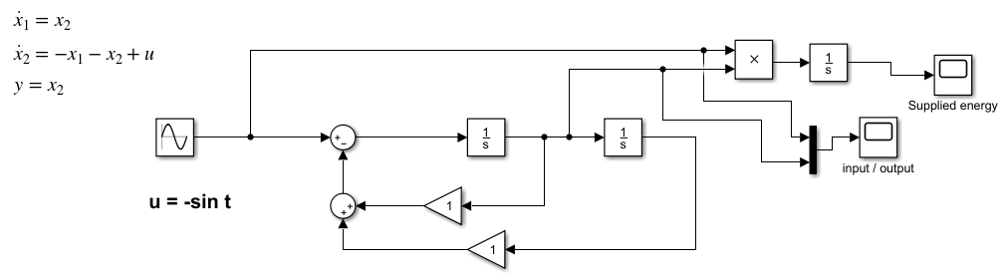

Input / output / supplied energy ($u=\sin{t})$

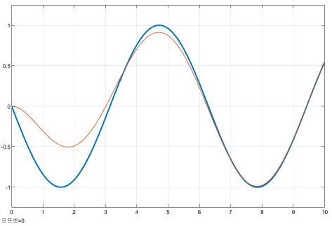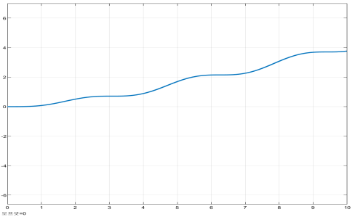

To simulate, all the initial conditions should be zero. This is a passive system with a storage function as a Lyapunov function. Hence $∀ u\left(t\right), \int_{0}^{t}{u\left(τ\right)y\left(τ\right)dτ}≥0$. Try another input to check

**Cautions!**

**Example. 2**

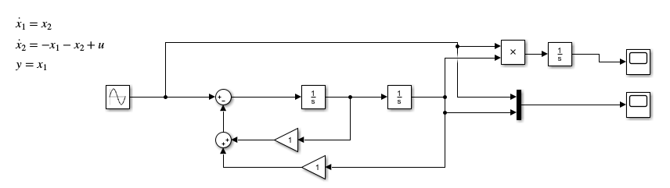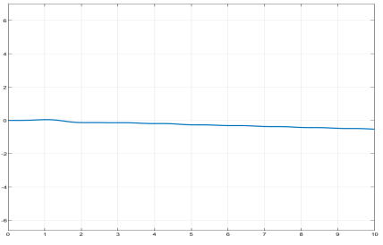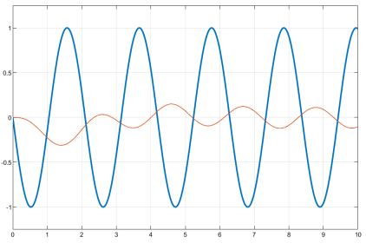

**Let us try the output $y=x_{1}$**

**Here I select input $u=-\sin{3t}$, then $, ∃T>0, \int_{0}^{T}{u\left(τ\right)y\left(τ\right)dτ}≥0$**

**Hence this is not passive!**

**Hence even if the system is asympt.stable, it may not be passive!!**

* In frequency domain -Passive – Nonpassive

**As in the class, positive real transfer function is introduced. By definition $G(s)$ is positive real if**

1. It is Hurwitz
2. And $G\left(jω\right)+G^{T}(-jω)$ is positive real.

Hence I will use this..

Ex. 1 Nyquist plot $G\left(s\right)=\frac{s}{s^{2}+s+1}$

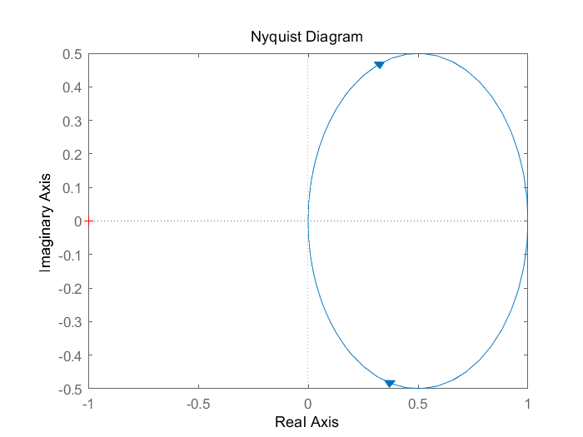

It is positive definite. 🡪 passive

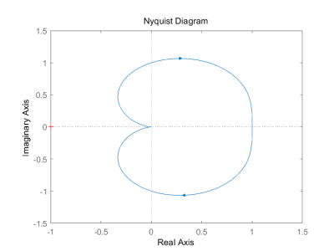Ex.2 Nyquist plot $G\left(s\right)=\frac{1}{s^{2}+s+1}$

It is not positive real !! 🡪 not passive

* In time domain -Passive – Nonpassive

It is unknown what is the characteristics to discriminate between passive and non-passive in time domain. However there is **sufficient condition** is

If the output is moving the opposite direction to the input indirection. There is an example Tut_Week_5.

%%% The EnD %%%

HW_6.1 : $f\left(x\right)=x$

6.1.1) Since $xf\left(x\right)=x^{2}>0 , x≠0$. It is passive. In the simulation, with $u\left(t\right)=\sin{t }$,with

$V\left(x\right)=a\int_{0}^{x}{sds}$, $u^{T}y≥\dot{V}$ so that it is passive

In the figure, the blue trajectory is the **time derivative** of a positive semi definite function $\dot{V}$ and the red is the $u^{T}y$, shows $u^{T}y≥ \dot{V}$

Or we may check

$$\int_{0}^{t}{u^{T}\left(τ\right)y\left(τ\right)dτ≥ 0}$$

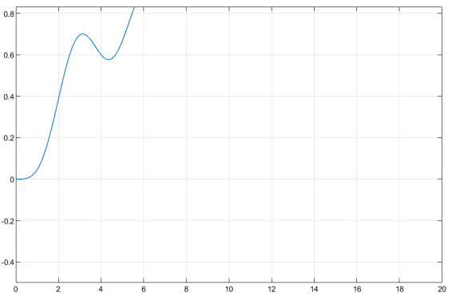

So that at least $t∈\left[0 20\right],$ the energy is

If the input $u\left(t\right)= -\sin{t}$, still the energy is positive

6.1.2) Here ,

- Let $u=\sin{t}$ then the energy $$\int_{0}^{t}{u^{T}\left(τ\right)y\left(τ\right)dτ≥ 0}$$

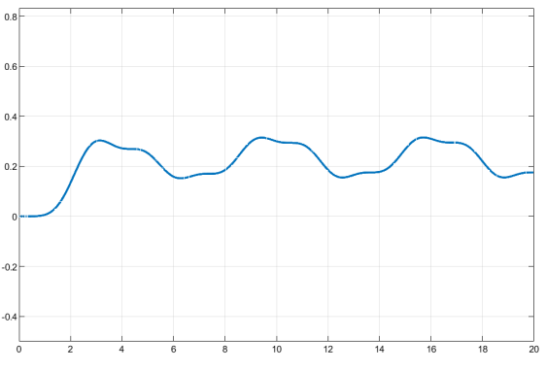

However, $u=-\sin{t}$,

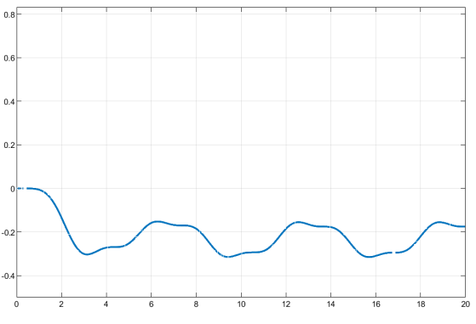

The energy is negative, so that this system is not-passive.

6.1.3) If $f\left(t\right)=x(t)$, with $u\left(t\right)=1 , t≥0$ it is passive…in fact by definition , the energy is always positive $∀u, ∀ t, t≥0$

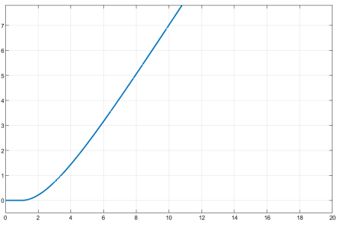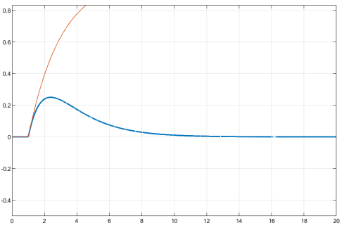

HW_6.2

6.2.1 See

6.2.2 If run the simulation, $u=1,$ it is divergent. The reason is at $x=1$, it is not stable(why?)

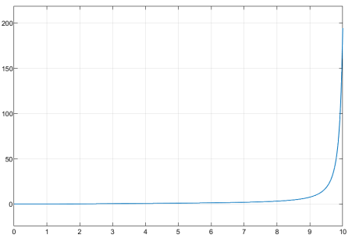

6.2.3. It is not passive since if $u\left(t\right)= -3\sin{t}$, $\int_{0}^{t}{u\left(τ\right)y\left(τ\right)dτ}<0$

%% comment : $h\left(x\right)= -x+x^{2}$ is not in the Sector. However, if $h\left(x\right)=x+x^{2}+x^{3}$ is in the sector $\left[1, ∞\right].$ Why?. Hence if $h\left(x\right)=x+x^{2}+x^{3}$, the closed system is passive(in fact, it is exponentially stable) %%

6.3 (Ex.5.5): pendulum equation

$${\dot{x}}_{1}=x_{2}, {\dot{x}}_{2}=-\sin\left(x_{1}\right)-bx_{2}+u, y=x_{2}$$

6.3.1 See Simulink

6.3.2. See

6.3.3 It is passive. Here there are two equilibrium points as $x=(0,0), x=(π,0)$. You may guess when $x_{1}≠0, π$, the pendulum is convergent to $x=(0,0)$ without input, i.e., it is passive.

If you linearize this, then you may guess it is asymptotic stable in **some bounded region** so that you may define **the region of attraction**. However, by passivity theory, it is globally asymptotic stable if $-π< x_{1}<π$

%% Kim’s comment -- Remember one more time --

<https://www.mathworks.com/help/control/ug/about-passivity-and-passivity-indices.html>

For the linear system, in frequency domain, there may be defined a transfer function $G(s)$. Now there are Hurwitz if poles of $G(s)$ has negative real values. Moreover the Hurwitz $G(s)$ is positive real if $G\left(s\right)+G(-s)$ is positive real.

1. What is the relation between the passivity and positive real transfer function? They are equivalent, i.e., if it is passive then its transfer function is positive real and vice versa. Now in non-linear system, there is no transfer function, but we may define the passivity by the definition
2. In the linear system, the positive real $G(s)$ has some characteristics

$\left|phase (G(s)\right|≤90$

* One of the zeros of $G(s)$ are in the right half plane.

1. The transient behavior of the non-positive real $G(s)$.

* Transient behavior of the output is opposite direction of the input in some time interval.
* You may not change the zeros of $G(s)$ for any state feedback.
* Hence it is more complicate to design a controller for stabilization.

1. The closed loop stability. See this closed loop system. Assume $G1(s)$ is positive real, then for any positive real $G2(s)$, the closed loop is asympt. stable.

